JOIN US FOR THE ANNUAL FAIR FOOD GRAZING PARTY ON SATURDAY
July 13, 2013 TO SUPPORT THE ILLINOIS STATE FAIR MUSEUM
Corndog Kickoff
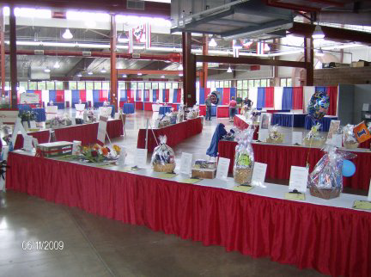The Corndog Kickoff is the annual benefit auction and food grazing party hosted by the Illinois State Fair Museum Foundation to generate support and funds for Illinois State Fair Museum. The event includes live and silent auctions, announcement of the Illinoisans of the Day, local entertainment, carnival games, and of course – FAIR FOOD!
The Corndog Kickoff will be held Saturday, July 13, 2013 ~ 5:30 p.m. at the Orr Building on the Illinois State Fairgrounds. Event includes fair food grazing and beverages (soda, beer and wine). Live music by local band, live and silent auction, Illinoisian of the Day Presentations.
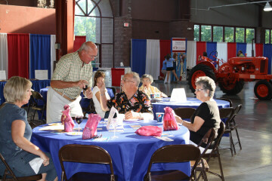Everyone who LOVES the Illinois State Fair is invited! Tickets are available to purchase in advance ~ $40 each or Table of 8 ~ $280; ~ $50 each at the door. Ticket price includes all fair food grazing and beverages (soda, beer and wine). Live music by local band, live and silent auction, Illinoisian of the Day Announcements and Presentations.
About the Illinois State Fair Museum Foundation
Started in 2006, the Illinois State Fair Museum Foundation is dedicated to preserving, promoting and understanding the rich heritage, traditions and history of the Illinois State Fair. It is the goal of the Foundation to support a permanent museum to house displays of historic memorabilia and provide year-round exhibits and programs for all Fair lovers. The Illinois State Fair Museum is located in the north end of the Grandstand.
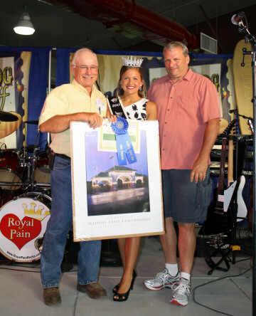 For More Information
217-558-0863 or 217-415-4408 www.illinoisstatefairmuseum.org

